**Supplementary Materials for**

**Impact of systematic factors on the outbreak outcome of novel coronavirus disease (COVID-19) in China**

Zicheng Cao1*, Feng Tang1*, Cai Chen1, Chi Zhang1, Yichen Guo1, Ruizhen Lin1, Zhihong Huang1, Yi Teng1, Ting Xie1, Yutian Xu2, Yanxin Song3, Feng Wu1, Peipei Dong1, Ganfeng Luo1, Yawen Jiang1, Huachun Zou1, Yao-Qing Chen1, Litao Sun1, Yuelong Shu1, Xiangjun Du1

1. School of Public Health (Shenzhen), Sun Yat-sen University, Guangzhou, P. R. China
2. School of Intelligent Systems Engineering, Sun Yat-sen University, Guangzhou, P. R. China
3. Lingnan College, Sun Yat-sen University, Guangzhou, P. R. China

* Contributed equally

**Corresponding Author:**

Dr. Xiangjun Du

School of Public Health (Shenzhen), Sun Yat-sen University

Guangzhou, 510006, P. R. China

Phone: +86- 02083226383

Email: duxj9@mail.sysu.edu.cn

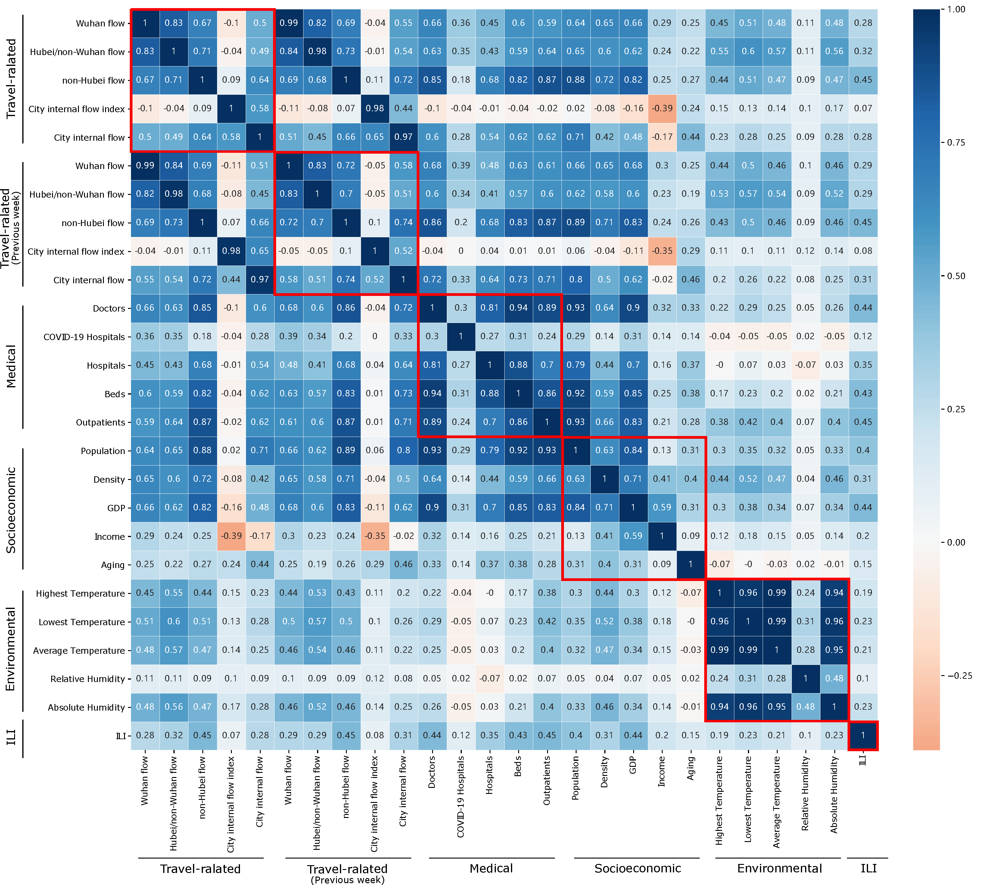

**Figure S1: Correlation matrix between factors.** Spearman correlation coefficients are color coded and factors from the same group are circled.

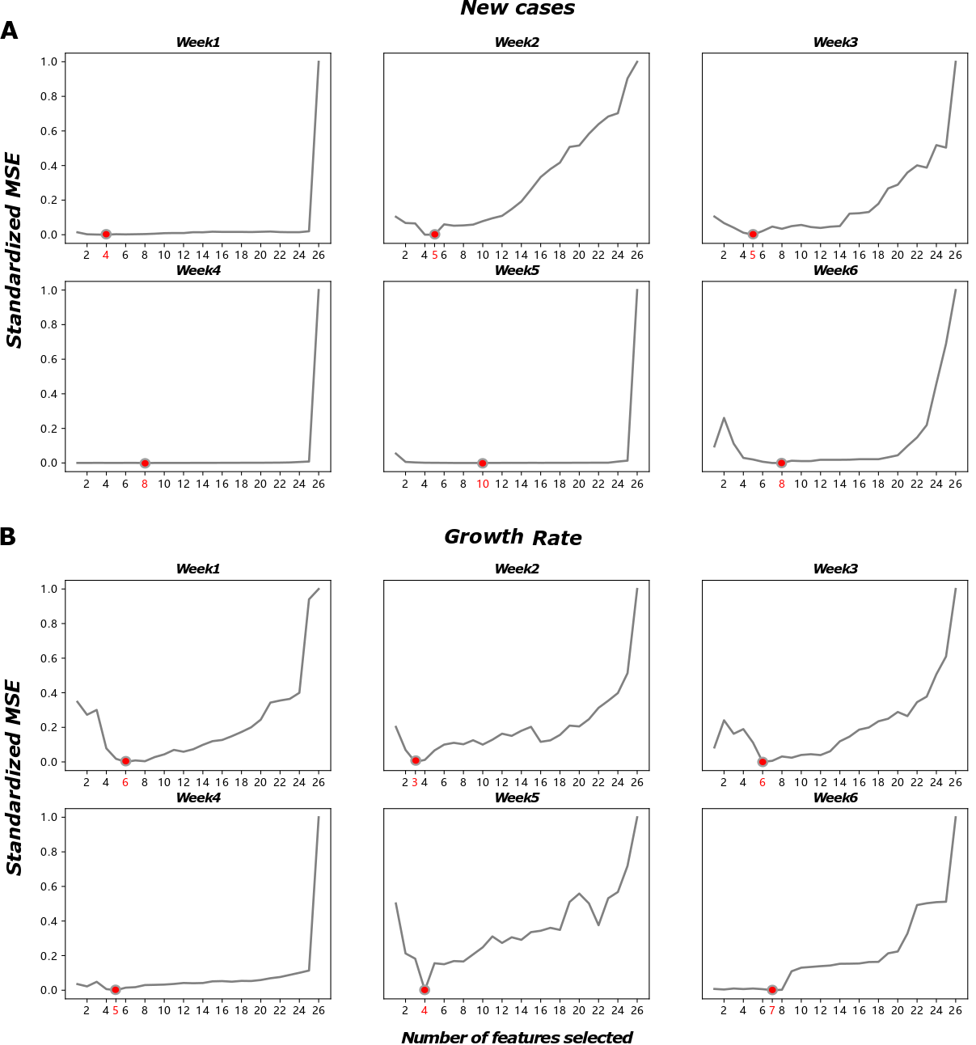

**Figure S2: Feature selection curve for new cases (A) and growth rate (B).** The optimal number of features selected is indicated by the red circle. Standardized mean squared error (MSE) was used in this study for selecting important features.

**Table S~~1~~2. Contribution percentage of factors.** Average contribution percentage is calculated as the mean of the contribution percentage across six weeks. Group contribution percentage is calculated as the sum of the individual contribution for factors within the group and shown at the end of each group.

|  |  |  |  |  |  |  |  |  |  |  |  |  |  |  |  |  |  |  |  |
| --- | --- | --- | --- | --- | --- | --- | --- | --- | --- | --- | --- | --- | --- | --- | --- | --- | --- | --- | --- |
| Factor | Week1  New Cases Growth Rate | | Week2  New Cases Growth Rate | | Week3  New Cases Growth Rate | | Week4  New Cases Growth Rate | | | | Week5  New Cases Growth Rate | | | Week6  New Cases Growth Rate | | | Average  New Cases Growth Rate | | |
| Wuhan flow | 0 | 0 | 0.45 | 0 | 0.58 | 0.13 | | 0 | | 0 | | 0 | 0.33 | | 0 | 0 | | 0.17 | 0.08 |
| Hubei/non-Wuhan flow | 0 | 0 | 0 | 0 | 0.19 | 0.22 | | 0 | | 0 | | 0 | 0 | | 0 | 0 | | 0.03 | 0.04 |
| non-Hubei flow | 0.20 | 0 | 0 | 0.25 | 0 | 0 | | 0 | | 0 | | 0.04 | 0 | | 0 | 0 | | 0.04 | 0.04 |
| City internal flow index | 0 | 0 | 0 | 0 | 0 | 0 | | 0 | | 0 | | 0 | 0 | | 0 | 0 | | 0 | 0 |
| City internal flow | 0 | 0 | 0.12 | 0 | 0 | 0 | | | 0 | 0.25 | | 0.10 | 0 | | 0.28 | 0 | | 0.08 0.04 | |
| **Travel-related** | **0.20** | **0** | **0.57** | **0.25** | **0.77** | **0.35** | | **0** | | **0.25** | | **0.14** | **0.33** | | **0.28** | **0** | | **0.32** | **0.20** |
|  |  |  |  |  |  |  | |  | |  | |  |  | |  |  | |  |  |
| Wuhan flow | 0.49 | 0 | 0 | 0 | 0.13 | 0 | | | 0.31 | 0.08 | | 0.49 | 0 | | 0.51 | 0 | | 0.32 0.01 | |
| Hubei/non-Wuhan flow | 0 | 0 | 0.22 | 0 | 0 | 0.14 | | 0 | | 0.21 | | 0.06 | 0 | | 0 | 0.16 | | 0.05 | 0.09 |
| non-Hubei flow | 0 | 0.29 | 0 | 0 | 0 | 0.13 | | | 0 | 0 | | 0 | 0 | | 0 | 0.13 | | 0 0.09 | |
| City internal flow index | 0 | 0 | 0 | 0 | 0 | 0 | | | 0.32 | 0 | | 0 | 0 | | 0 | 0.11 | | 0.05 0.02 | |
| City internal flow | 0 | 0 | 0.09 | 0 | 0.06 | 0 | | 0 | | 0 | | 0 | 0 | | 0 | 0.03 | | 0.03 | 0.01 |
| **Travel-related (Previous week)** | **0.49** | **0.29** | **0.31** | **0** | **0.19** | **0.27** | | **0.63** | | **0.29** | | **0.55** | **0** | | **0.51** | **0.43** | | **0.45** | **0.21** |
|  |  |  |  |  |  |  | |  | |  | |  |  | |  |  | |  |  |
| Doctors | 0 | 0 | 0 | 0 | 0 | 0 | | 0 | | 0 | | 0 | 0 | | 0.03 | 0.06 | | 0.01 | 0.01 |
| COVID-19 Hospitals | 0 | 0.13 | 0 | 0 | 0 | 0 | | 0.07 | | 0 | | 0 | 0.20 | | 0 | 0 | | 0.01 | 0.06 |
| Hospitals | 0.12 | 0 | 0 | 0 | 0 | 0 | | 0 | | 0 | | 0 | 0 | | 0 | 0 | | 0.02 | 0 |
| Beds | 0 | 0 | 0 | 0 | 0 | 0 | | 0 | | 0 | | 0.04 | 0 | | 0 | 0 | | 0.01 | 0 |
| Outpatients | 0 | 0 | 0 | 0 | 0 | 0 | | 0 | | 0 | |  | 0 | | 0 | 0 | | 0 | 0 |
| **Medical** | **0.12** | **0.13** | **0** | **0** | **0** | **0** | | **0.07** | | **0** | | **0.04** | **0.20** | | **0.03** | **0.06** | | **0.05** | **0.07** |
|  |  |  |  |  |  |  | |  | |  | |  |  | |  |  | |  |  |
| Population | 0 | 0.13 | 0 | 0 | 0 | 0 | | 0.09 | | 0 | | 0.10 | 0.21 | | 0 | 0 | | 0.03 | 0.06 |
| Density | 0 | 0 | 0.13 | 0 | 0 | 0.26 | | 0 | | 0 | | 0.05 | 0 | | 0.09 | 0.31 | | 0.05 | 0.10 |
| GDP | 0 | 0 | 0 | 0 | 0 | 0 | | 0.05 | | 0 | | 0.01 | 0.26 | | 0 | 0 | | 0.01 | 0.04 |
| Income | 0 | 0.20 | 0 | 0 | 0 | 0.13 | | 0 | | 0 | | 0 | 0 | | 0 | 0 | | 0 | 0.05 |
| Aging | 0 | 0.06 | 0 | 0 | 0 | 0 | | 0.01 | | 0.13 | | 0 | 0 | | 0 | 0 | | 0 | 0.03 |
| **Socioeconomic** | **0** | **0.39** | **0.13** | **0** | **0** | **0.39** | | **0.15** | | **0.13** | | **0.16** | **0.47** | | **0.09** | **0.31** | | **0.09** | **0.28** |
|  |  |  |  |  |  |  | |  | |  | |  |  | |  |  | |  |  |
| Highest Temperature | 0 | 0.18 | 0 | 0 | 0 | 0 | | 0 | | 0 | | 0 | 0 | | 0 | 0 | | 0 | 0.03 |
| Lowest Temperature | 0 | 0 | 0 | 0.35 | 0 | 0 | | 0 | | 0 | | 0 | 0 | | 0.01 | 0 | | 0 | 0.06 |
| Average Temperature | 0 | 0 | 0 | 0 | 0 | 0 | | 0 | | 0 | | 0 | 0 | | 0 | 0 | | 0 | 0 |
| Relative Humidity | 0.19 | 0 | 0 | 0 | 0 | 0 | | 0 | | 0 | | 0.10 | 0 | | 0.08 | 0 | | 0.06 | 0 |
| Absolute Humidity | 0 | 0 | 0 | 0 | 0.03 | 0 | | 0.06 | | 0.33 | | 0 | 0 | | 0 | 0 | | 0.02 | 0.06 |
| **Environmental** | **0.19** | **0.18** | **0** | **0.35** | **0.03** | **0** | | **0.06** | | **0.33** | | **0.10** | **0** | | **0.09** | **0** | | **0.08** | **0.14** |
|  |  |  |  |  |  |  | |  | |  | |  |  | |  |  | |  |  |
| ILI | 0 | 0 | 0 | 0.41 | 0 | 0 | | 0.09 | | 0 | | 0 | 0 | | 0 | 0.20 | | 0.01 | 0.1 |
| **ILI** | **0** | **0** | **0** | **0.41** | **0** | **0** | | **0.09** | | **0** | | **0** | **0** | | **0** | **0.20** | | **0.01** | **0.1** |